Account. Java

TestAccount.java

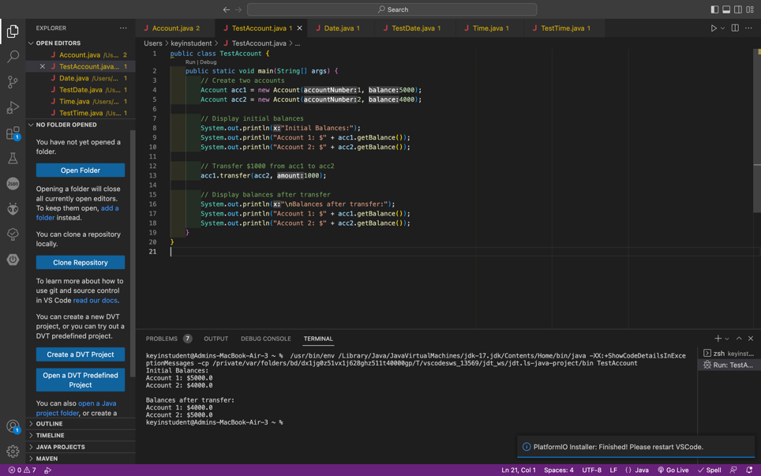

Date.java

TestDate.java

Time.java

TestTime.java

